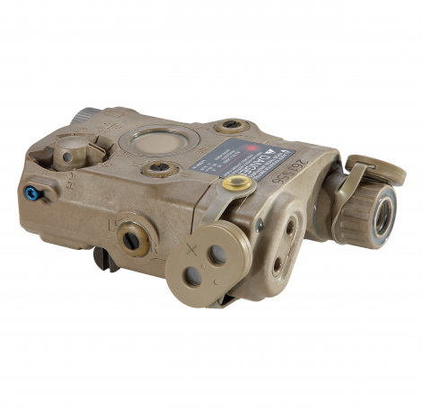

The Advanced Target Pointer/ Illuminator/ Aiming Light (ATPIAL) is the standard issue laser module for the U.S. Warfighter. Designed and built as the next generation weapon-mountable IR laser/Illuminator, it is the battlefield replacement for the venerable AN/PEQ-2A which has faithfully served US Military Forces and Law Enforcement Agencies for years. One of the key improvements in the ATPIAL is the addition of a co-aligned visible laser diode which increases functionality, allowing for use without night vision devices. The visible laser is slaved with the IR laser pointer, meaning a zero with one, insures the same zero with the other. This is extremely advantageous because you can positively zero or check your zero during the day using a simple boresight technique. The ATPIAL’s increased functionality comes at almost half the weight and size of its predecessor.
The exceptional functionality of this unit gives you everything you could want in a single compact package. Its design seats the unit low on the rail, and wraps around the Picatinny for a snag-resistant, low profile. This is accomplished by utilizing a recessed rail-grabber mount. The recessed controls are located on top of the housing for easy access in the field with gloves. The body housing is constructed of a high-density/ impact polymer and feels extremely robust. The material takes a lot of weight out of the unit, which is appreciated during long hours of carrying a rifle. The ATPIAL also features a rear-facing battery compartment which allows the user to remove the battery (we all know not to store our high-end NV and laser equipment with batteries installed, right?) without removing the unit. A molded-in lanyard loop rounds out the back. Windage and Elevation are adjusted with tiny screws on the top and sides of the unit. Each adjustment produces a positive click. The requirement of a tool to adjust windage/elevation is nice since it keeps the adjustment points low profile so they do not catch in the field.
The ATPIAL (AN/PEQ-15) is the standard issue weapon-mounted laser unit for U.S. Warfighters.
IR Lasers are restricted to Law Enforcement and Government sales only and cannot be sold to civilians. Purchase of IR Laser equipment can only occur at the Department, Agency, or Unit level. IR Lasers cannot be sold to individual Law Enforcement, Military, Government, or Contractor personnel. No exceptions. If you are a government employee and would like to purchase an IR laser, you must have your agency place the order for you. We do not make the rules, but we do follow them. These lasers are regulated by the FDA (Food & Drug Administration). Price inquires must include an email request from an official government or government contractor email address. All ITAR restrictions apply.
Manufacturer:
L3/ Insight Technology
NSN:
5855-01-534-5931
Dimensions:
4.6″(L) x 2.8″(W) x 1.6″(H)
Weight:
7.5 oz. w/ Battery
Power:
One (1) 3V DL123A Battery
Battery Life:
>6 Hours in Dual High
Waterproof:
6 Meters for One Hour
Warranty:
1 Year Warranty
IR Laser Spec:
——————————-
IR Class:
IIIa (Low), IIIb (High)
IR Output:
0.6mW (Low), 25mW (High)
IR Beam:
0.5 mRad Divergence
IR Laser WL:
820nm – 850nm
IR Range:
>600 Meters (Low), 2,000 Meters (High)
Visible Laser Spec:
——————————-
Vis. Class:
IIIa
Vis. Output:
4.0 mW
Vis. Beam:
0.5 mRad Divergence
Vis. WL:
605nm – 665nm Wavelength
Vis. Range:
>25 Meters in Direct Sun
IR Illuminator Specs:
——————————-
Class:
IIIb
Output:
3.5mW (Low), 30mW (High)
Divergence:
1-105 mRad
Wavelength:
820nm – 850nm
Range:
>600 Meters (Low), 2,000 Meters (High)
Includes:
Soft Carry Case, Operator’s & Unit Maintenance Manual, Quick Reference Card, One (1) 3V DL123A Lithium Battery, Allen Wrench (3/32 Hex), Illuminator Diffuser, Aiming Exit Port Cover, Remote Cable Switch, Velcro Tape Fastener, Optical Pattern Generators

